

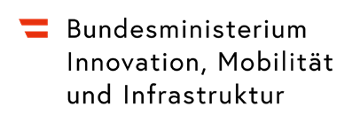


Target groups and subjects

- Secondary level 1–2
- Business Studies (BWL)
- Geography
- Project-based instruction
- Education for Sustainable Development (ESD / BNE)


Exercise: How far does my clothing travel?


Duration
15–45 minutes

Type of exercise
- Individual, pair, or group work
Difficulty 

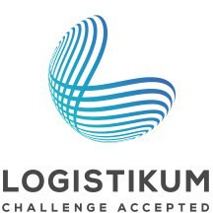
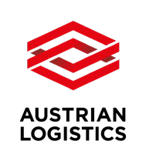

Curriculum Links
- Globalization
- Fundamentals of Logistics
- Geography
Short Description
In this exercise, students explore the global supply chain of clothing using tangible, real-life examples. They investigate the origin of their own garments, calculate transport routes, and reflect on the ecological and social impacts of the fashion industry.
Learning Objectives

- Students can identify the countries of origin of their clothing based on labels.
- They can research transport routes and means of transport and trace them geographically.
- They can present the global supply chain of a product as an example.

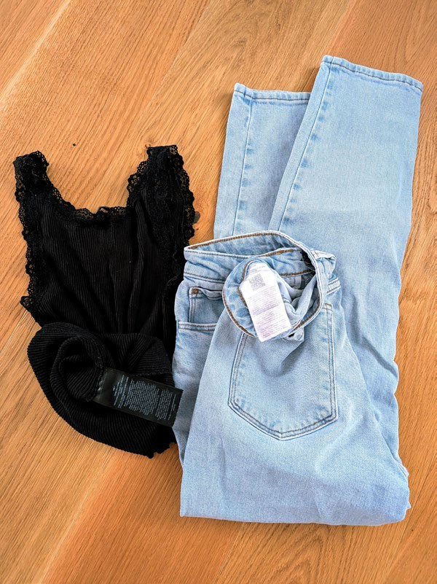
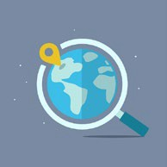

How far does my clothing travel?

Investigate as a team where your clothing comes from and how far it has traveled before reaching you. Use a world map, research the means of transport, and reflect on the impacts.
Task Overview:
- You can work individually or in small groups.
- Examine the labels of 3–5 clothing items and note the countries of origin.
- Mark the countries on a world map and look at possible transport routes.
- Research which means of transport may have been used to ship the clothing.
- Create a poster or a presentation with your results.
- Discuss the reflection questions as a team.

Origin of the Clothes

Item of clothing | Country of origin | Material | Kilometers traveled

How far does my clothing travel?

Clothing item 1: Means of transport and travel route

Section | Means of transport | Distance (km) | Remarks

Clothing item 2: Means of transport and travel route
Item of clothing | Means of transport | Material | Kilometers traveled

Clothing item 3: Means of transport and travel route
Item of clothing | Means of transport | Material | Kilometers traveled

How far does my clothing travel?

Clothing item 4: Means of transport and travel route

Section | Means of transport | Distance (km) | Remarks

Clothing item 5: Means of transport and travel route

Item of clothing | Country of origin | Material | Kilometers traveled

Reflection Questions
- Why is clothing transported over such long distances?

- What impact does this have on the environment and climate?

- What could be alternatives (e.g., local production, second-hand)?

